CMPE314 – SOFTWARE ENGINEERING
Lab 5 Solution: Activity Diagrams
Project: FitTrack – Personal Fitness Companion
Group 3/1: Tawfig Malik (22115813), Lahsen Aittjiou (22118897), Hassan Eihab HassanAli (22211935)

Part 1 – Library Kiosk activity diagram
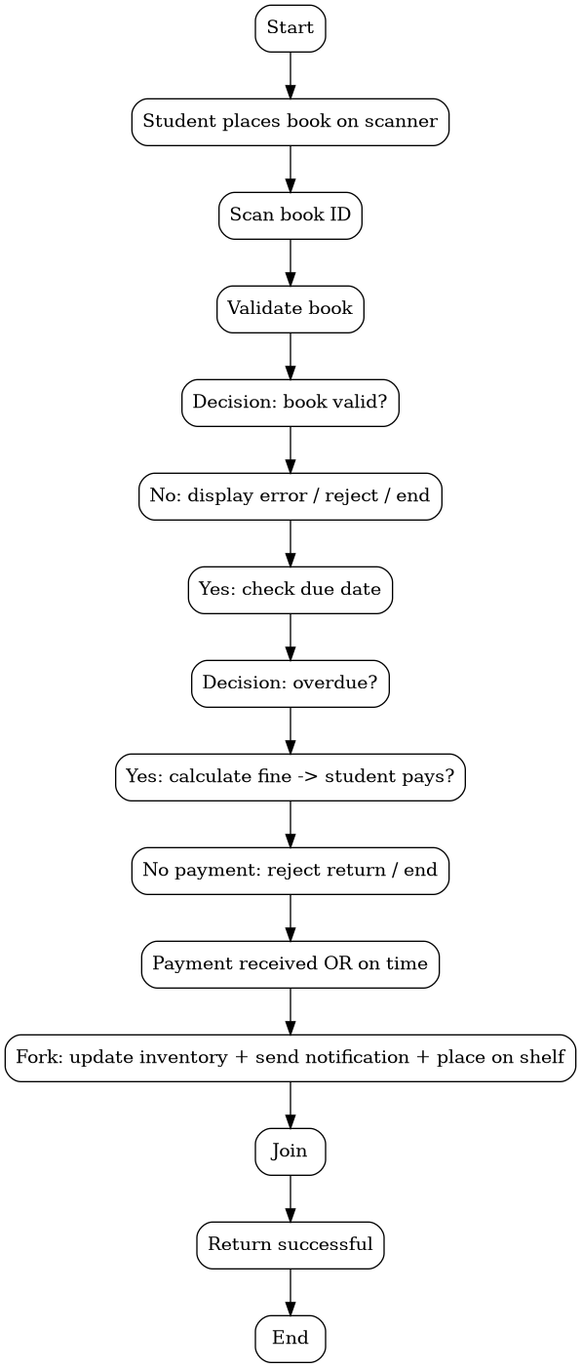
The workflow checks book validity and due date. If the book is overdue, fine payment is required before acceptance. After acceptance, inventory update, notification, and shelf placement can happen in parallel.

Part 2 – FitTrack activity diagram: Log Meal
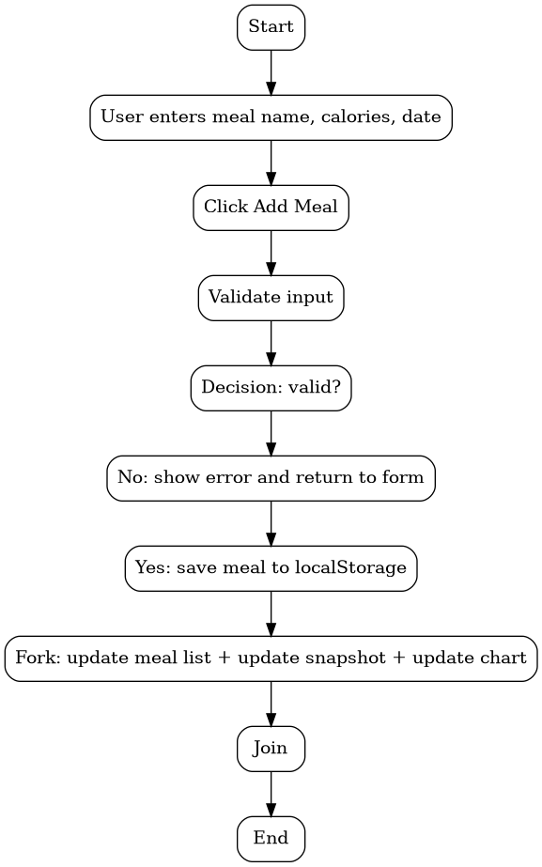
This use case is different from Lab 4. The user enters meal details, the system validates the data, and valid meals are saved. After saving, the list, today snapshot, and weekly chart update together.
function addMeal() {
const name = mealName.value.trim();
const calories = Number(mealCalories.value);
const date = mealDate.value;
if (!name || calories < 0 || !date) {
alert("Enter a valid meal name, calories, and date");
return;
}
const meals = JSON.parse(localStorage.getItem(`meals_${currentUser}`)) || [];
meals.push({ id: Date.now(), name, calories, date });
localStorage.setItem(`meals_${currentUser}`, JSON.stringify(meals));
refreshDashboard();
}

